PROJECT - REPORT
ESTIMATION OF BUSINESS EXPENSES



TEAM MEMBER:(TEAM ID - NM 2023TMID06266)
- Hameethap (asunm1319222104926)
- Akash(asunm1319BSCPY2122045)
S. Ayyanar(asunm1319222104918)
M. Ezhilarasan(asun131922104920)

PROJECT FLOW
- DEFINE PROBLEM/ PROBLEM UNDERSTANDING
- Specify the business problem
- Business requirement
- Literature surey
DATA COLLECTION AND EXTRACTION
- COLLECT THE DATA set
- Connect data set with tableau
DATA PREPARTION
- Prepare the data for visualization
DATA VISULAZATION
- No of unique visualization
DASHBOARD
- Response and design of dashboard
STORY
- No of scenes of story
PERFORAMENCE TESTING
- Utilization of data filters
- No of calculation field
- No of visulazation/ graphs
PUBLISHING
❖ Publishing dashboard and story to tableau public
➢ PROJECT DEMONSTRATION AND
DOCUMENTATION
❖ Record explanation video for project end to end solution
❖ Project documentation step by step project development

INSTRODUCTION
1.1: OVERVIEW:
Estimation of business refers to the process of forecasting or approximating various aspects of a business's operations, finances, and performance. It involves analyzing data and making informed guesses about future outcomes to assist in decision-making and planning. This can include estimating sales, expenses, profits, market trends, and other critical factors to guide strategic decisions and budgeting within a company. Estimation is a vital component of business management and helps businesses set goals and make informed choices based on anticipated outcomes.
1.2 PURPOSE:
*Planning and Budgeting: Estimations help in setting financial goals, creating budgets, and allocating resources effectively.

*Decision Making: They assist in making informed decisions regarding investments, expansion, cost-cutting, and pricing strategies.

#Definition of Empathy Map
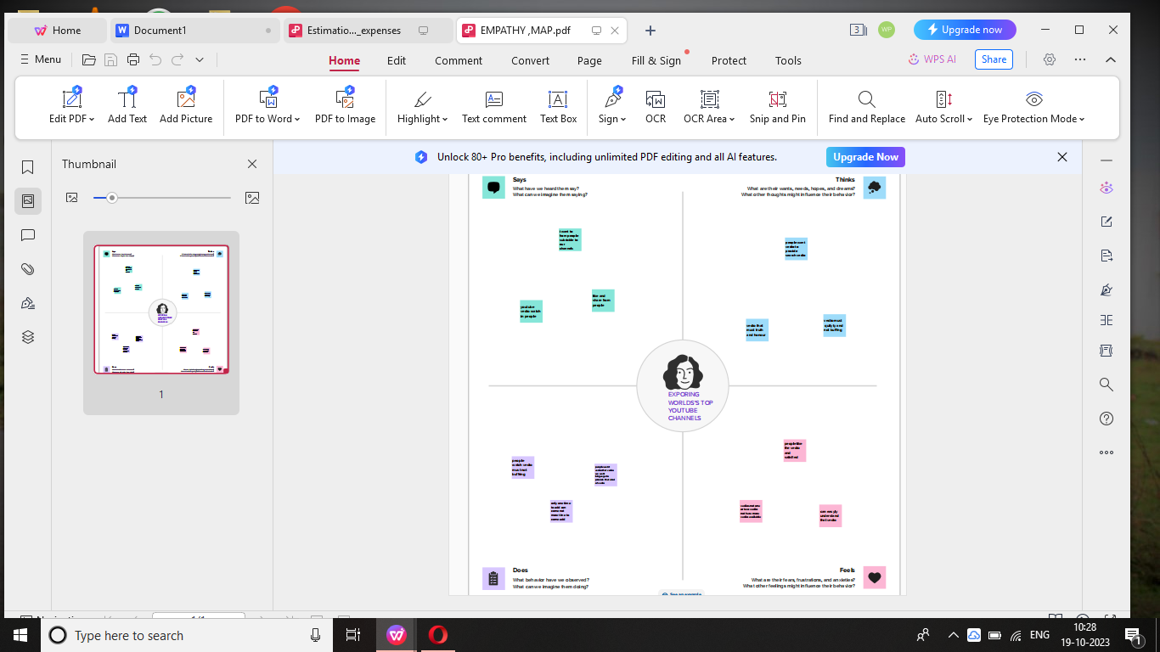

#Brainstrom
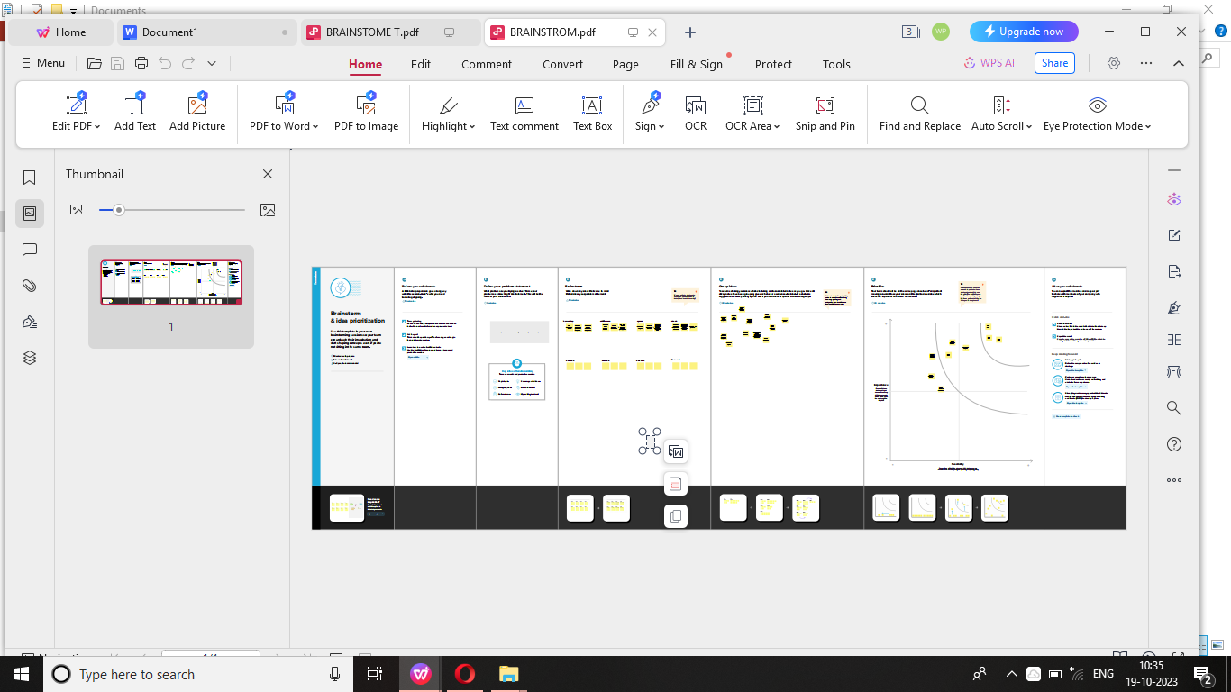

Result
Using tableau software we analysied the dataset of estimation of Business expenses.

# Annual pay roll
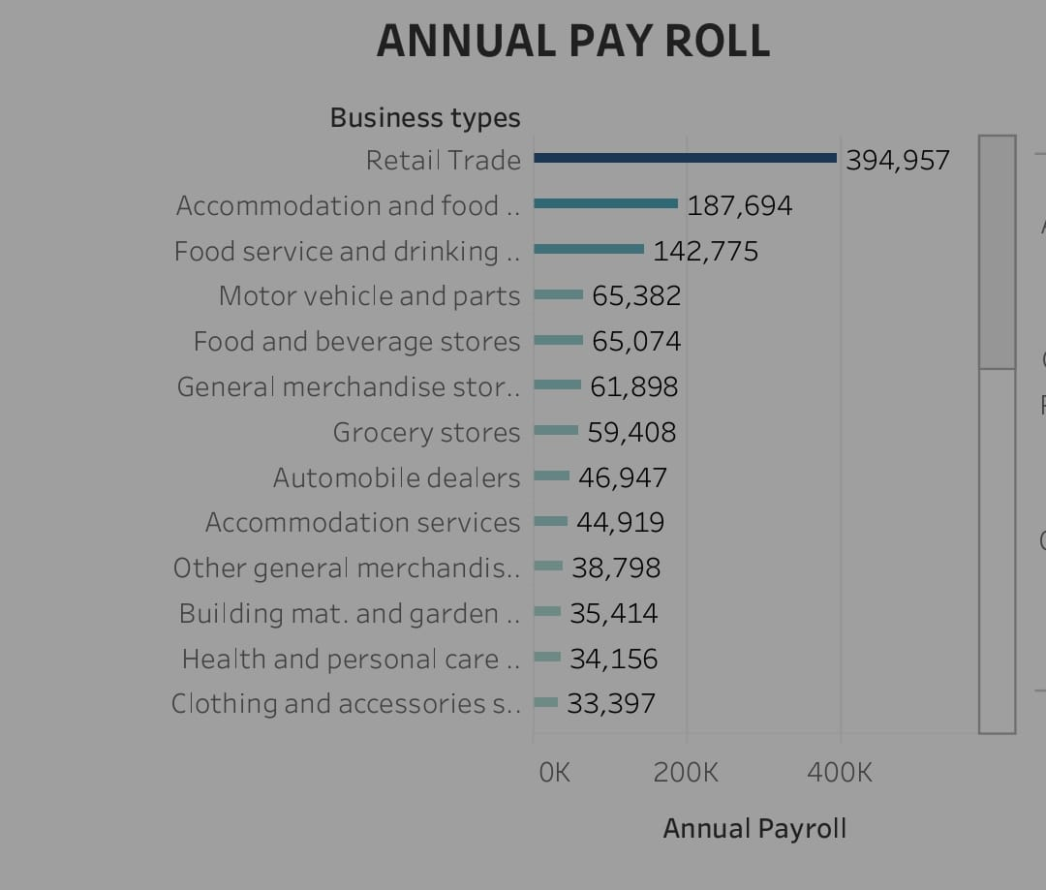
#Power expenditure
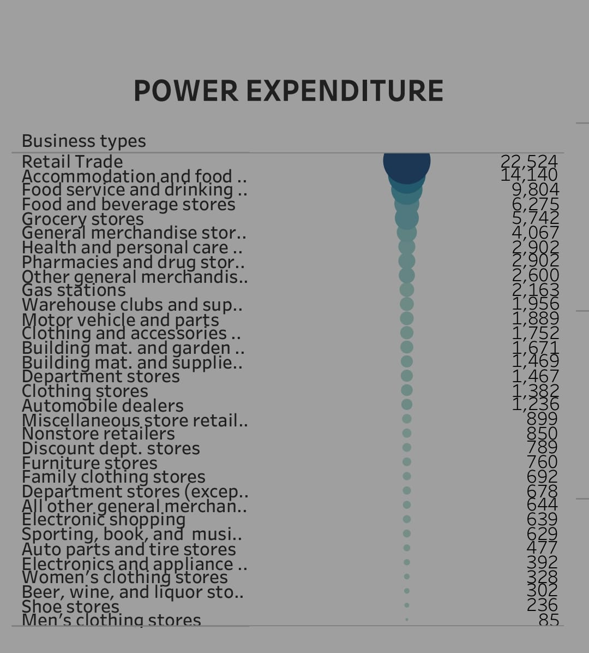

#Contract labour vs employee

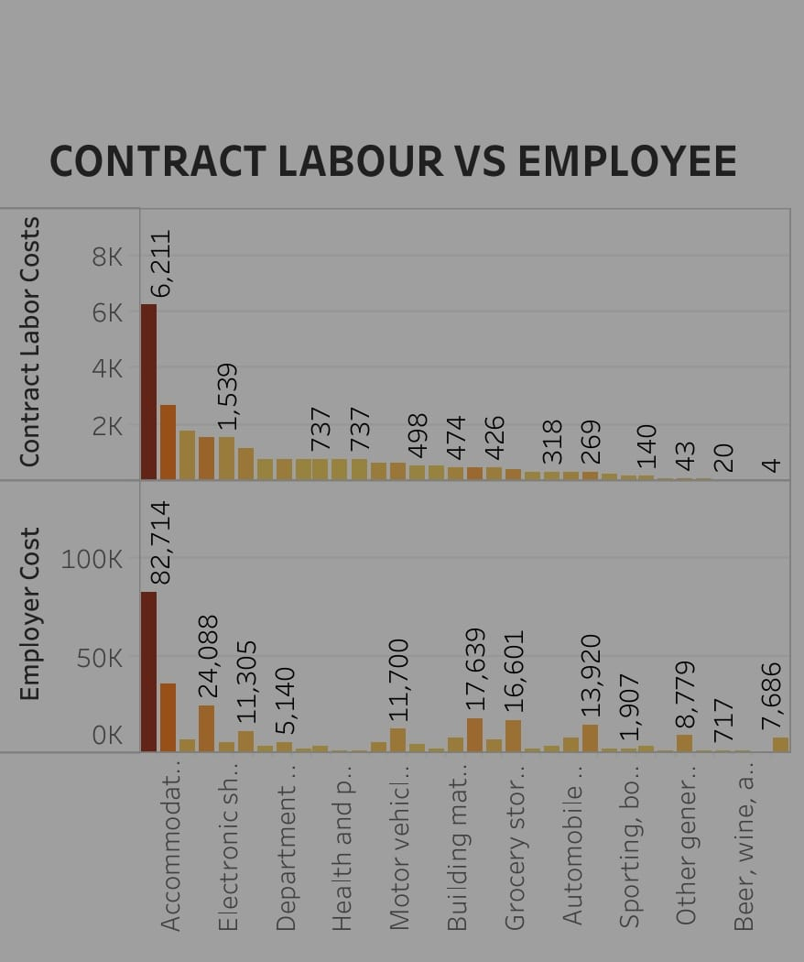

#Employee cost(insurance vs pension)
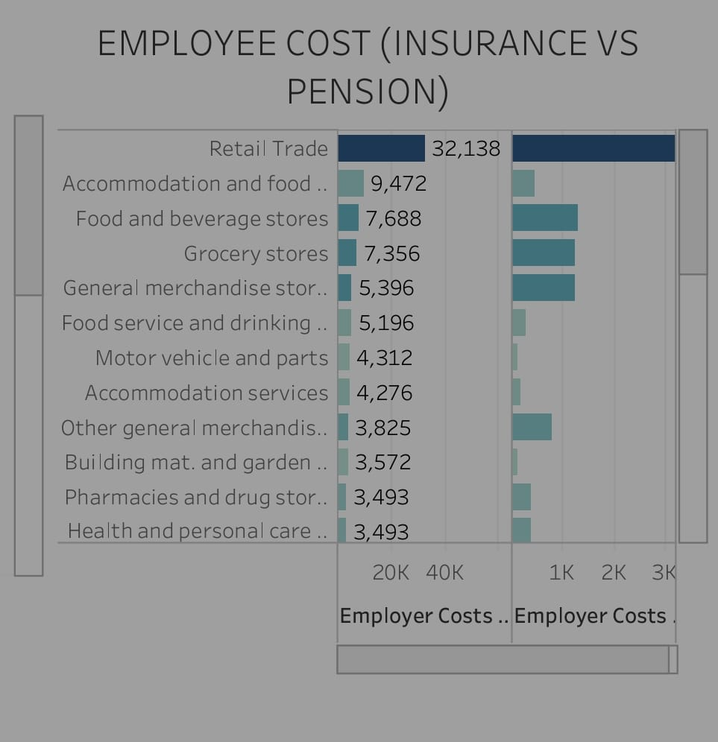

#Advertisment cost
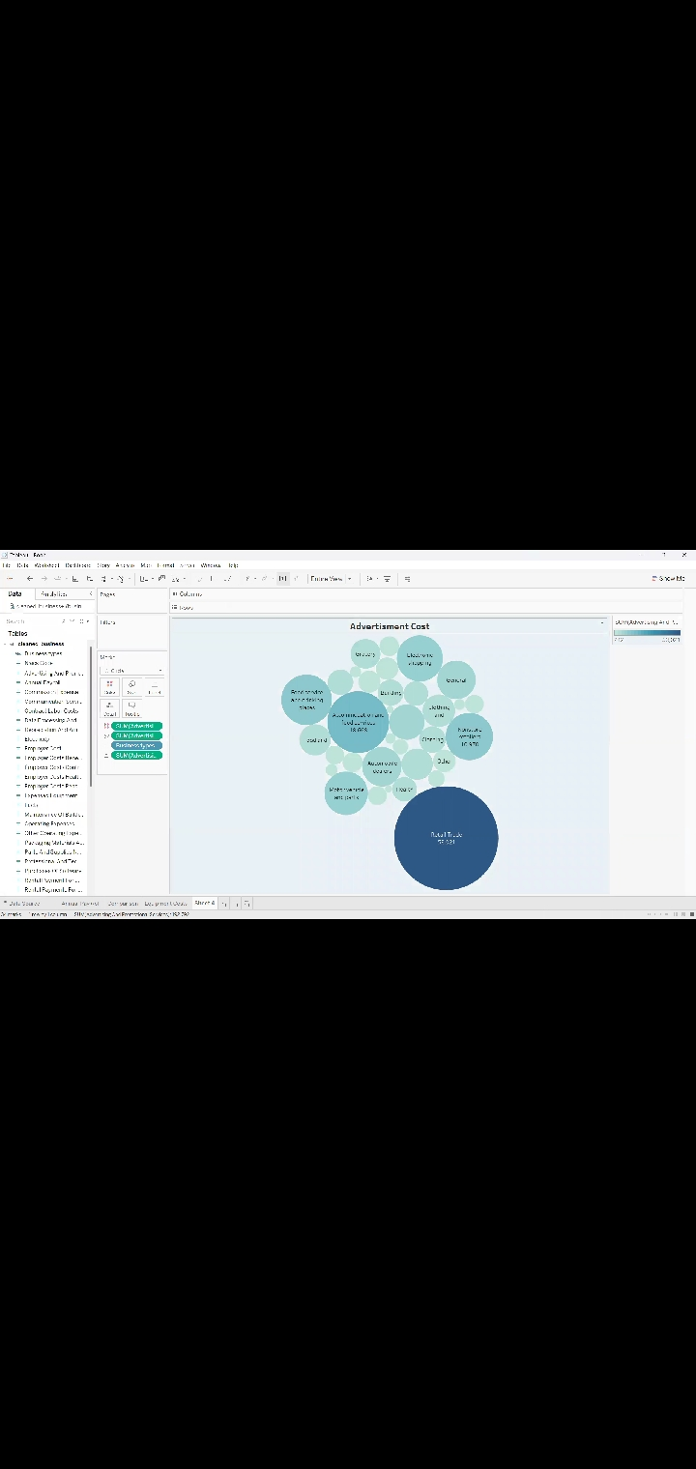

Dashboard
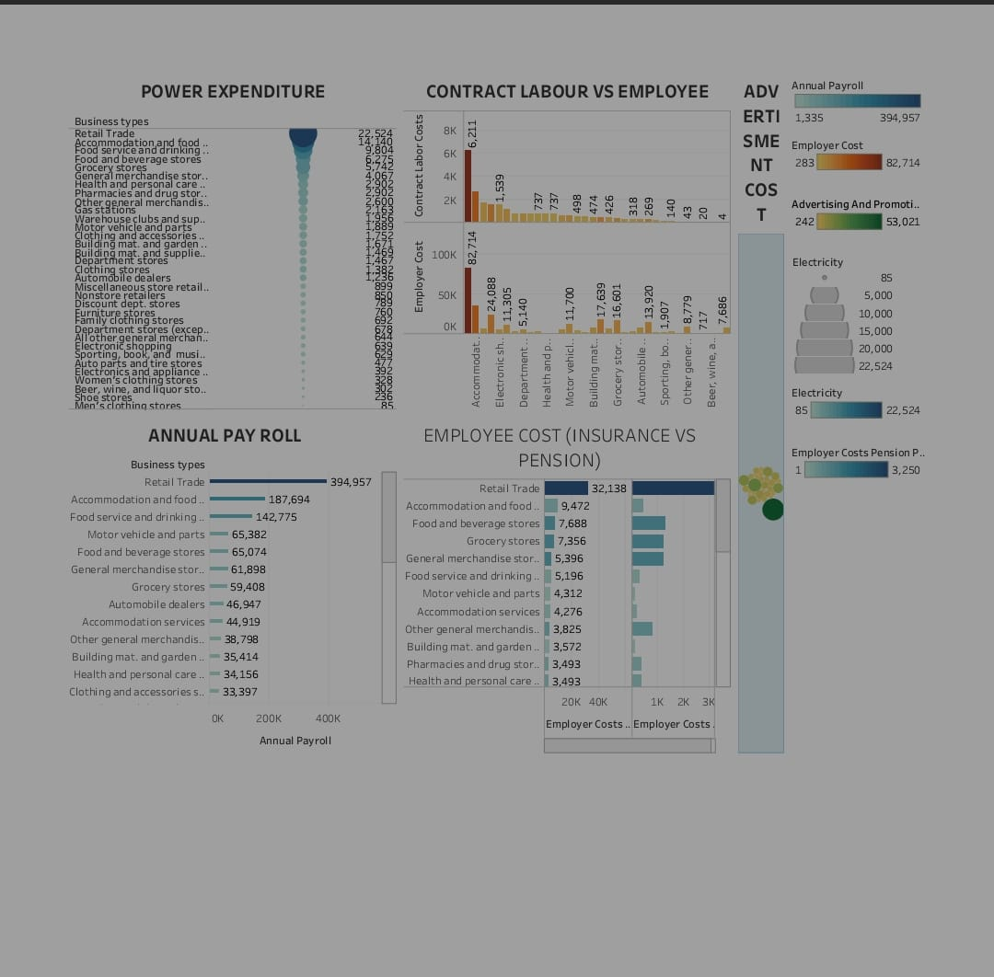

Story

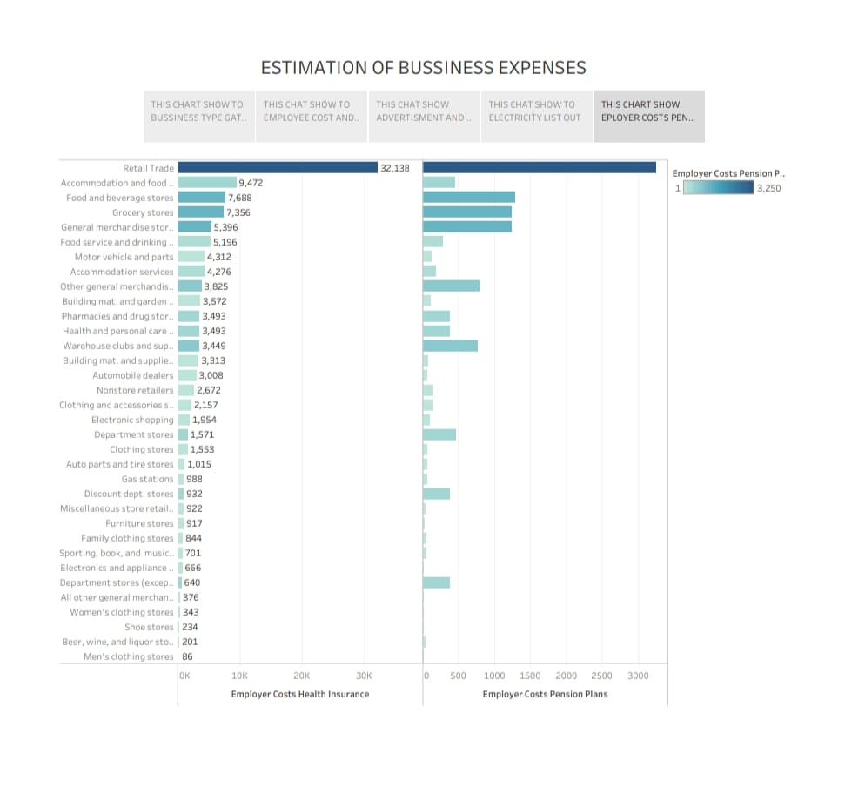

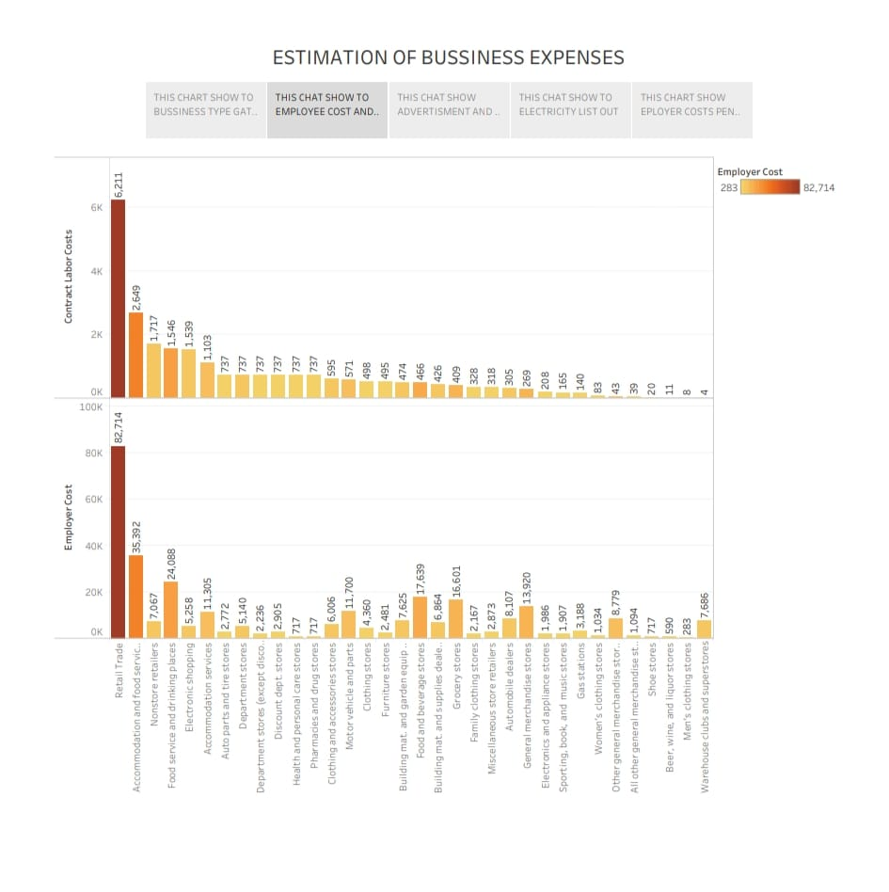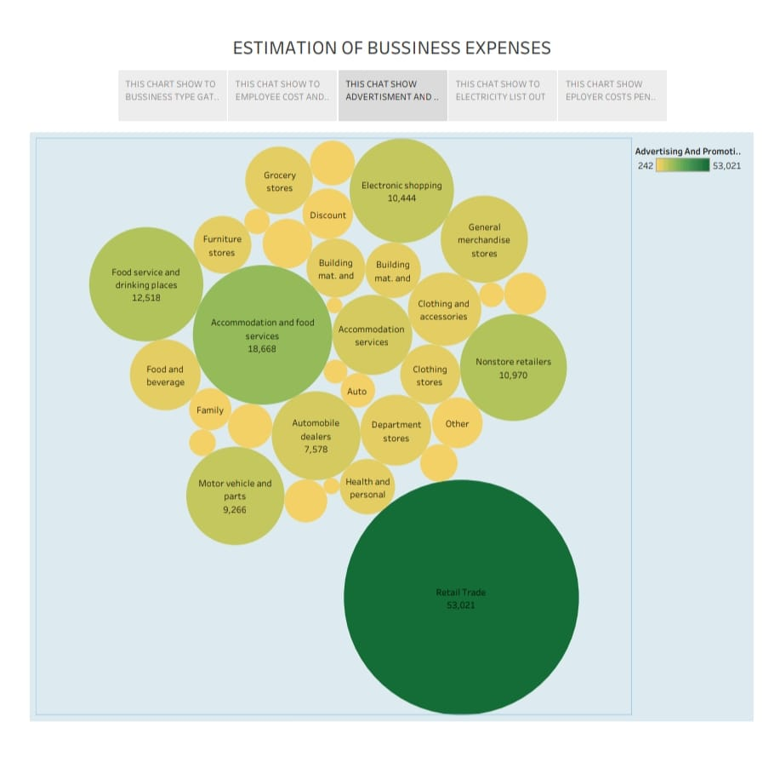

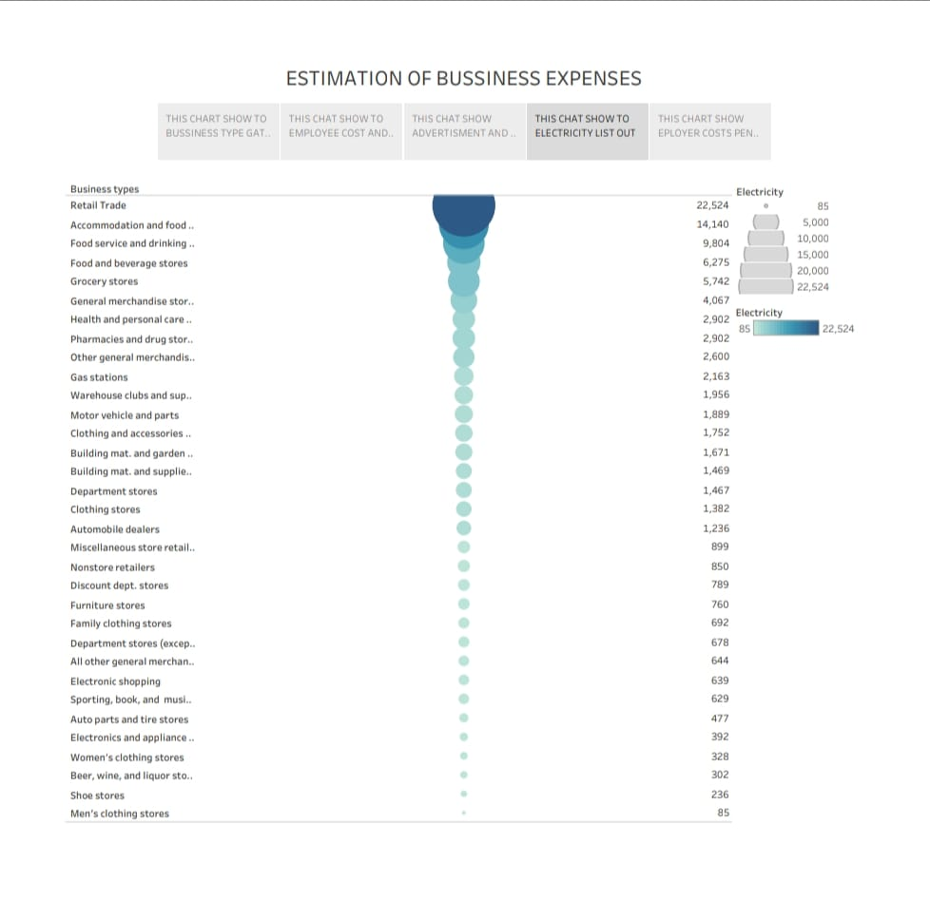

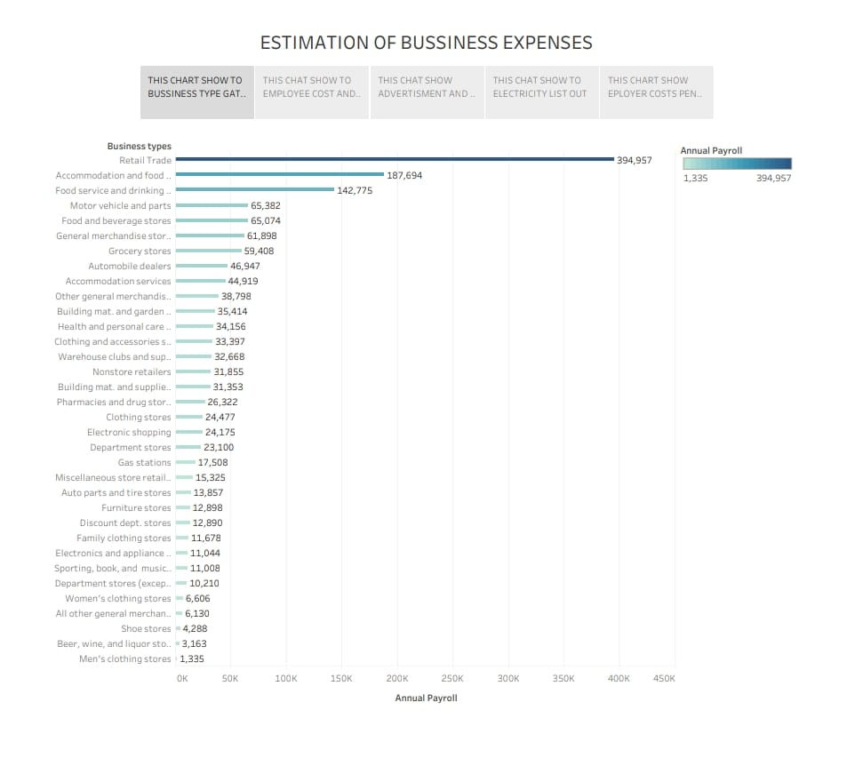

Advantages & Disadvantages

Advantages:
- Cost Savings: Estimating expenses can be more cost-effective than meticulous tracking of every small expense, especially for smaller
- Time Efficiency: Estimation can save time compared to detailed record-keeping, allowing employees to focus on core business activities.
- Flexibility: Estimations provide flexibility in budgeting and planning, enabling businesses to adapt to changing circumstances more easily.
- Reduced Administrative Burden: Estimating expenses can reduce the administrative workload associated with tracking and recording each expense.

Disadvantages:
- Accuracy: Estimations may not be precise and can lead to inaccuracies in financial reporting and budgeting.
- Risk of Overspending: Businesses might overspend if they rely solely on estimates, as they may underestimate actual expenses.
- Limited Insights: Estimation can limit your ability to gain deep insights into spending patterns and cost control.
- Compliance Issues: In some industries and for tax purposes, accurate expense tracking is essential, and estimation may lead to compliance issues.

Applications
- Expense Entry: Allow users to input various expense items, such as rent, utilities, employee salaries, and more.
- Categorization: Categorize expenses into different categories (e.g., office supplies, marketing, travel) for better tracking.
- Receipt Upload: Offer an option to attach receipts or invoices for each expense.
- Expense Date: Include a date field to track when each expense occurred.
- Calculation: Automatically calculate total monthly or yearly expenses.
- Exporting Data: Allow users to export their expense data in different formats (PDF, CSV, Excel).
- Security: Ensure data security and privacy compliance (e.g., GDPR, HIPAA, etc.).

Conclusion :
- cost estimation is an important component of project management that ensures projects are finished on schedule and within budge.

Future Scope:

the process of forecasting the financial and other resources needed to complete a project within a defined scope.
- A business estimate is a document detailing how much you plan on charging a customer for a good or service. It breaks down costs line by line (e.g., each cost for providing drywall installation) so customers know where the total is coming from.

